Nama : Andyan Yogawardhana

NIM : 21/482180/PA/21030

Kelas : KOMB1

Tugas 2 – Array dan Linked List

1. Penjumlahan Elemen

A. Array

1. import java.util.Scanner;
2. public class Jumlah {
3. public static void main(String[] args) {
4. ArrayJumlah array = new ArrayJumlah();
5. array.inputArray();
6. array.jumlahArray();
7. }
8. }
9. class ArrayJumlah {
10. private double[] arr;
11. private double jumlah;
12. private int banyakData;
13. public double[] inputArray() {
14. Scanner input = new Scanner(System.in);
15. System.out.print("Banyak data : ");
16. banyakData = input.nextInt();
18. arr = new double[banyakData];
19. System.out.println("Array dengan " + banyakData + " data");
20. for(int i = 0; i < banyakData; i++) {
21. System.out.print("Data ke-" + i + " : ");
22. arr[i] = input.nextDouble();
23. }
25. input.close();
26. return arr;
27. }
28. public void jumlahArray() {
29. jumlah = 0;
31. for(int i = 0; i < arr.length; i++) {
32. jumlah += arr[i];
33. }
35. System.out.println("Jumlah : " + jumlah);
36. }
37. }

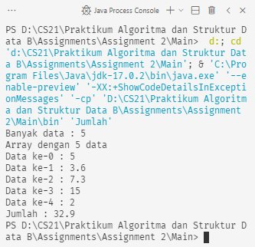

B. Linked List

1. import java.util.LinkedList;
2. import java.util.Scanner;
3. public class JumlahLinked {
4. public static void main(String[] args) {
5. List list = new List();
6. list.inputList();
7. list.jumlahLinked();
8. }
9. }
10. class List {
11. private LinkedList<Double> list;
12. private int banyakData;
13. private double data, jumlah;
15. public LinkedList<Double> inputList() {
16. list = new LinkedList<Double>();
18. Scanner input = new Scanner(System.in);
20. System.out.print("Banyak data : ");
21. banyakData = input.nextInt();
22. System.out.println("Linked list dengan " + banyakData + " data");
24. for(int i = 0; i < banyakData; i++) {
25. System.out.print("Data ke-" + i + " : ");
26. data = input.nextDouble();
27. list.add(data);
28. }
30. input.close();
31. return list;
32. }
34. public void jumlahLinked() {
35. jumlah = 0;
36. for(int i = 0; i < banyakData; i++) {
37. jumlah += list.get(i);
38. }
39. System.out.println("Jumlah : " + jumlah);
40. }
41. }

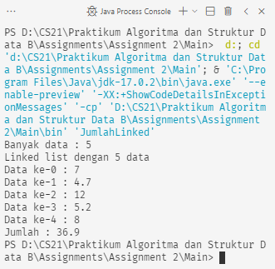

2. Kelipatan Tiga

1. public class Tiga {
2. public static void main(String[] args) {
3. ArrayLipat3 array = new ArrayLipat3();
4. array.inputArray();
5. array.displayLipat();
6. array.multiplyArray();
7. array.displayLipat();
8. }
9. }
10. class ArrayLipat3 {
11. int[] arr = new int[10];
13. public int[] inputArray() {
14. for(int i = 0; i < 10; i++) {
15. arr[i] = i \* 2;
16. }
17. return arr;
18. }
20. public int[] multiplyArray() {
21. for(int i = 0; i < 10; i++) {
22. arr[i] = arr[i] \* 3;
23. }
24. return arr;
25. }
27. public void displayLipat() {
28. System.out.print("Data : ");
29. for(int i = 0; i < 10; i++) {
30. System.out.print(arr[i] + " ");
31. }
32. System.out.println();
33. }
34. }

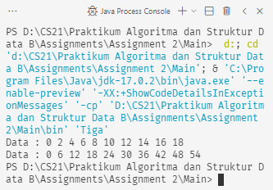

3. Membalik Kata / Kalimat

1. import java.util.Scanner;
2. public class Balik {
3. public static void main(String[] args) {
4. Kata kata = new Kata();
5. kata.inputKata();
6. kata.balikKata();
7. }
8. }
9. class Kata {
10. private String kata;
11. private char[] kataArray, balik;
12. public char[] inputKata() {
13. Scanner input = new Scanner(System.in);
15. System.out.print("Kata yang akan dibalik\t: ");
16. kata = input.nextLine();
18. balik = new char[kata.length()];
20. input.close();
21. return balik;
22. }
24. public char[] balikKata() {
25. kataArray = kata.toCharArray();
27. for(int i = 0; i < kata.length(); i++) {
28. balik[i] = kataArray[kata.length() - (i+1)];
29. }
30. displayBalik();
32. return balik;
33. }
35. public void displayBalik() {
36. System.out.print("Kata terbalik\t\t: ");
37. for(int i = 0; i < kata.length(); i++) {
38. System.out.print(balik[i]);
39. }
40. System.out.println();
41. }
42. }

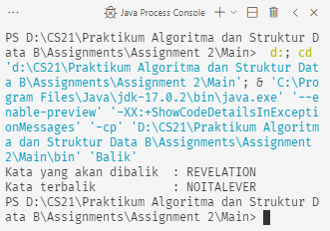

4. Cek Palindrom

1. import java.util.Scanner;
2. public class Palindrome {
3. public static void main(String[] args) {
4. KataPalindrom kata = new KataPalindrom();
5. kata.inputPalindrom();
6. kata.cekPalindrom();
7. }
8. }
9. class KataPalindrom {
10. private String kata, stringKataAsli, stringKataBalik;
11. private boolean isPalindrome = false;
12. private char[] kataAsli, kataBalik;
13. public String inputPalindrom() {
14. Scanner input = new Scanner(System.in);
15. System.out.print("Kata yang akan dicek : ");
16. kata = input.nextLine();
17. input.close();
18. return kata;
19. }
20. public void cekPalindrom() {
21. kataAsli = kata.toCharArray();
22. kataBalik = new char[kata.length()];
23. for(int i = 0; i < kata.length(); i++) {
24. kataBalik[i] = kataAsli[kata.length() - (i+1)];
25. }
27. stringKataAsli = new String(kataAsli);
28. stringKataBalik = new String(kataBalik);
29. if(stringKataAsli.equals(stringKataBalik)) {
30. isPalindrome = true;
31. }
32. if(isPalindrome) {
33. System.out.println("Kata \"" + kata + "\" adalah palindrom");
34. }
35. else {
36. System.out.println("Kata \"" + kata + "\" bukan palindrom");
37. }
38. }
39. }

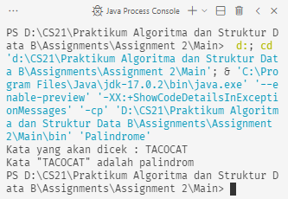

5. Biaya Parkir

1. public class Parkir {
2. public static void main(String[] args) {
3. Mobil nissan = new Mobil("Nissan", 2);
4. Mobil toyota = new Mobil("Toyota", 3);
5. Mobil honda = new Mobil("Honda", 10);
6. nissan.status();
7. toyota.status();
8. honda.status();
9. }
10. }
11. class Mobil {
12. private String model;
13. private int waktu, tarif;
14. public Mobil(String model, int waktu) {
15. this.model = model;
16. this.waktu = waktu;
17. }
18. public void status() {
19. this.tarif = 2000 \* waktu;
20. System.out.println("Model : " + model);
21. System.out.println("Waktu : " + waktu + " jam");
22. System.out.println("Tarif : Rp" + tarif);
23. System.out.println();
24. }
25. }

